**Game Doc:**

**Player is wearing a uniform and theres a machine gun in the asset pack if we go for the guard daughter story then we need her sprites of the daughter that fits with the game art . so I tried to cook this new story jisme wo soldier h joki is mysterious jungle ko escape karna chahta h.**

**I hope you like it: )**

**Story ;**

**It the time was of the World war I.** 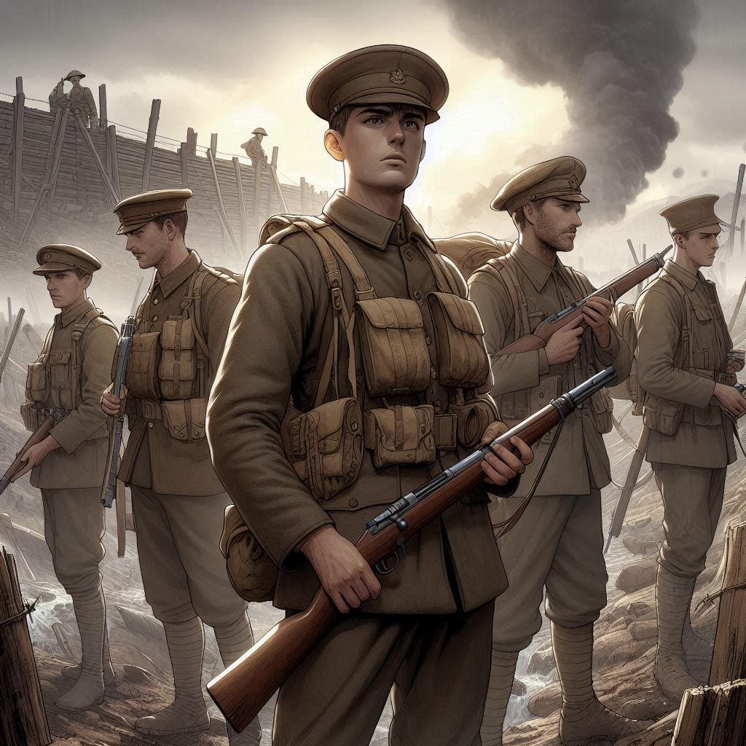

**Jake a young strong man who was the eldest son in his family of five his one little brother one little sister and his parents, gets his call to an adventure. Due to the war Jake with other boys of his hometown had to go to the battlefield faraway from their hometown as the enemies are dominating the war and their country need more men to defend.**

**Jack reaches the battle field and to their basecamp, everything familiar was left behind, the wind felt different, the trees , the grass everything but still the faces were familiar as they were from his own country.**

**They comfort each other by some chitchats and telling their stories and giving a basic intro to each other where they come from , what their aspirations are .**

**In the night time theres a blast ; while jake and his mates were resting. they run outside the camp and find out the enemies has attacked the one blast sound turned to many explosions jake has never seen something like this before; he is terrefied and shocked ,** 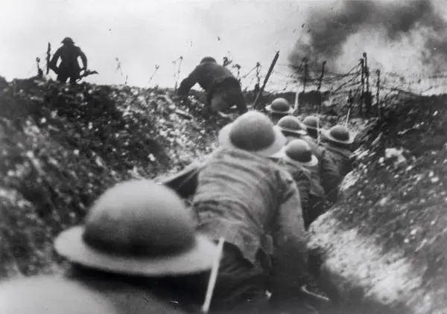

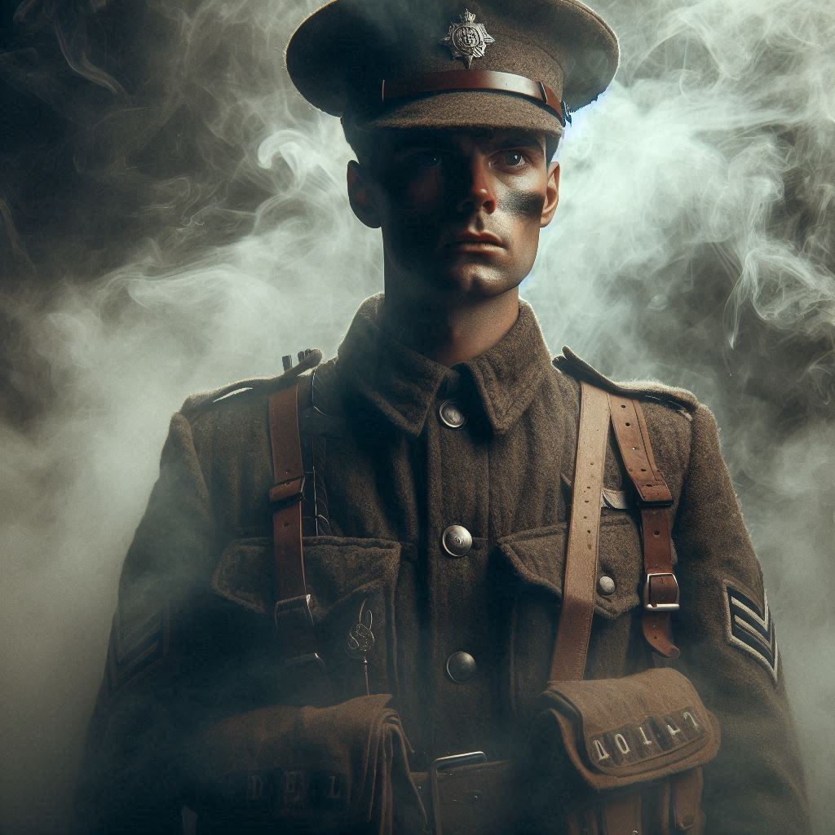**Suddenly the air felt heavier (enemies are using their newly invented chemical weapon) he could not breathe properly he runs involuntarily and after running some distance falls from the cliff covered with the snow and fell unconscious .**

**He wakes up (the game can start here) he realizes how he lost everything now he is in the middle of nowhere 1000 of miles away from his home he has flashbacks of the mates he lost yesterday and his family back in his town.** 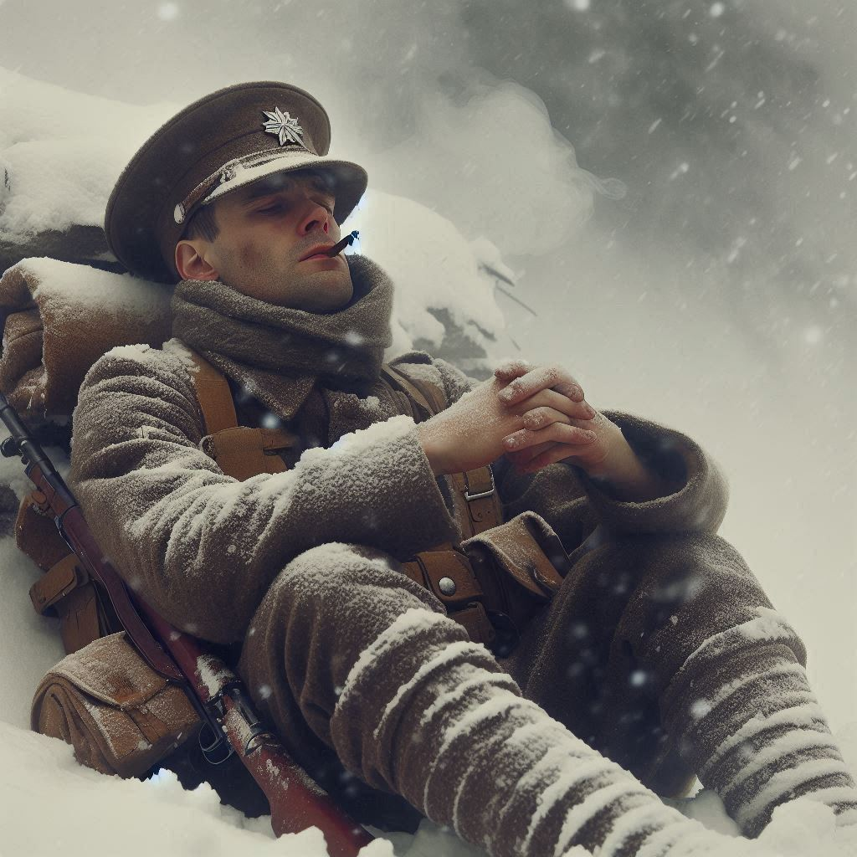

**He wishes to see his hometown once again and misses his family.** 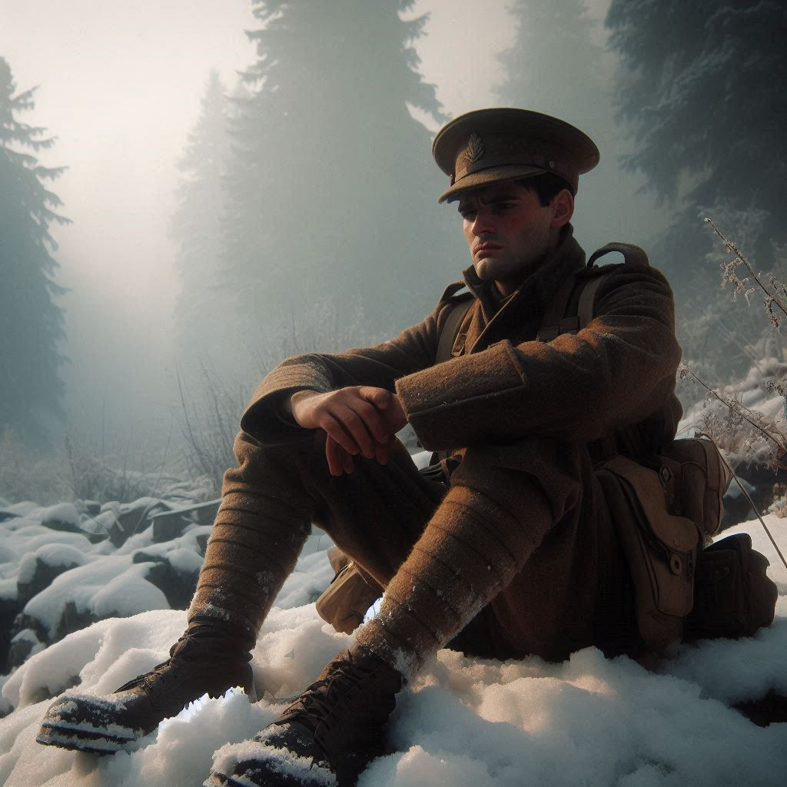

**At some distance he sees a man in uniform he takes a look the man turn back and jack notices that the man in the uniform has no skin on his face ,** 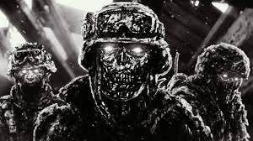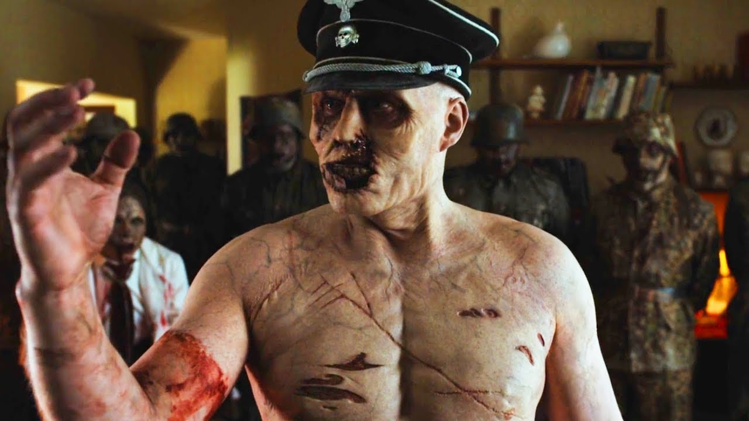

**The chemical gas succumbed the alive to death and made the dead alive.**

**The dead man,the snow (theres a snow and mushroom monster in the asset pack ) , even the small mushroom was eager to kill the hope that is left in jake**

**But jake’s will to see his home again made him a fearless cold survivor   
Jake is now in the war with the dead**

**~~Jake is~~ Jake in the wild ….**

**Tutorial level :**

**Easy level just to introduce controls.**

**Level with Ice monsters:**

**So there will be a level with Ice monsters .**

**It will be hard difficulty level so tiles are placed such a way it will be hard to jump**

**Player will first go directly to attack Ice monster it cant defeat them (they are immortal)**

**The puzzle:**

**Player will try to find other way then maybe he go for the ladder that takes to the tower if he plays around he will find out that the tower can be moved a little he pushes the tower the tower fells then the Ice monsters dies due to fire**

**Level with gun :**

**Player will keep going forward until he gets out of the jungle**

**Medium difficulty level**

**Player comes across a place with zombies and up above the a platform and behind the zombies there will be a gun, zombies have a key that will unlock the door to go forward**

**If the player directly goes to attack zombies he will lose as there are too many zombies the way to clear this level is go behind the zombies with the help of platform above them then get the gun kill em all then take the keys and use it to run away .[model image : Next Page]**

